After Registration -Additional ON LINE FORMS

Go to: canyonsdistrict.org
- Parents & Students
  - Skyward

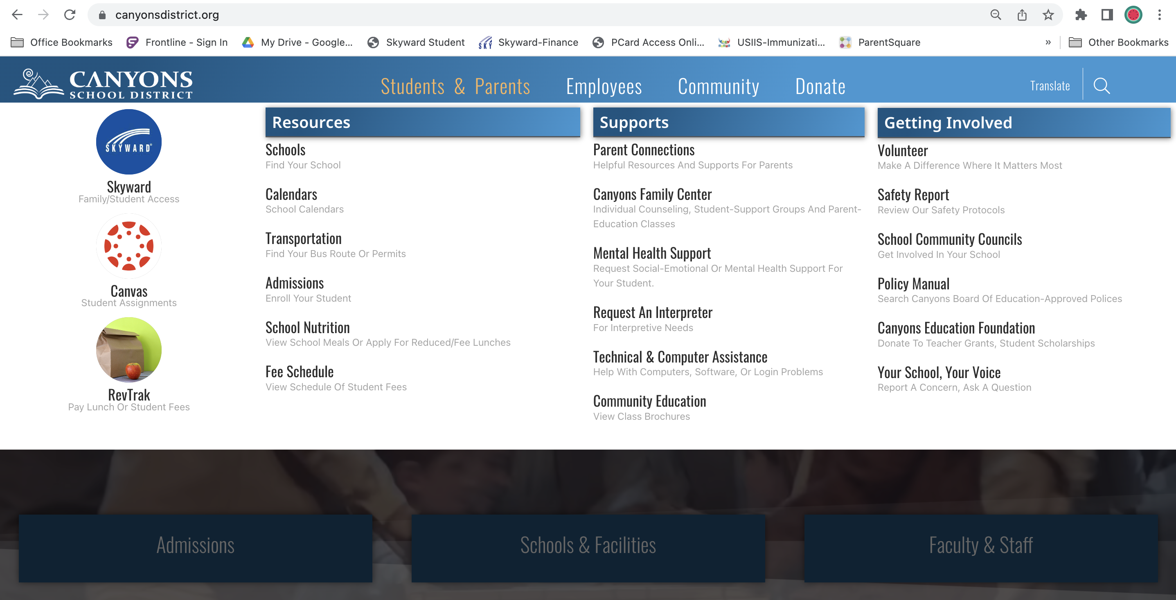

Your login is: see email
Your password is: see email

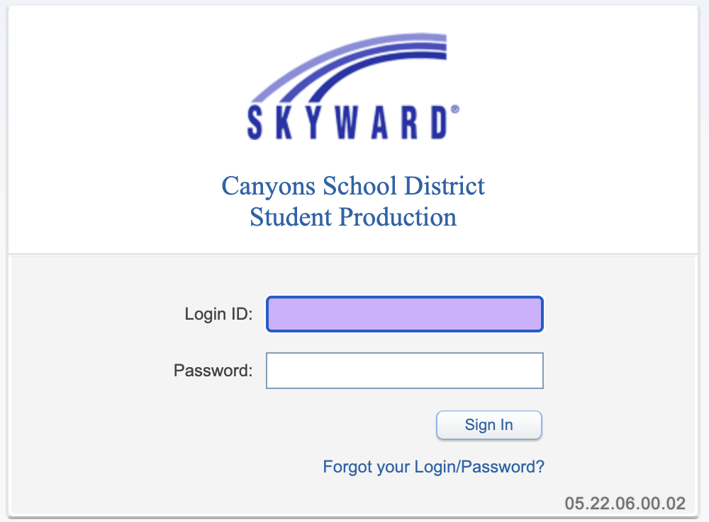

Go to back to school registration and pull down your child’s name.

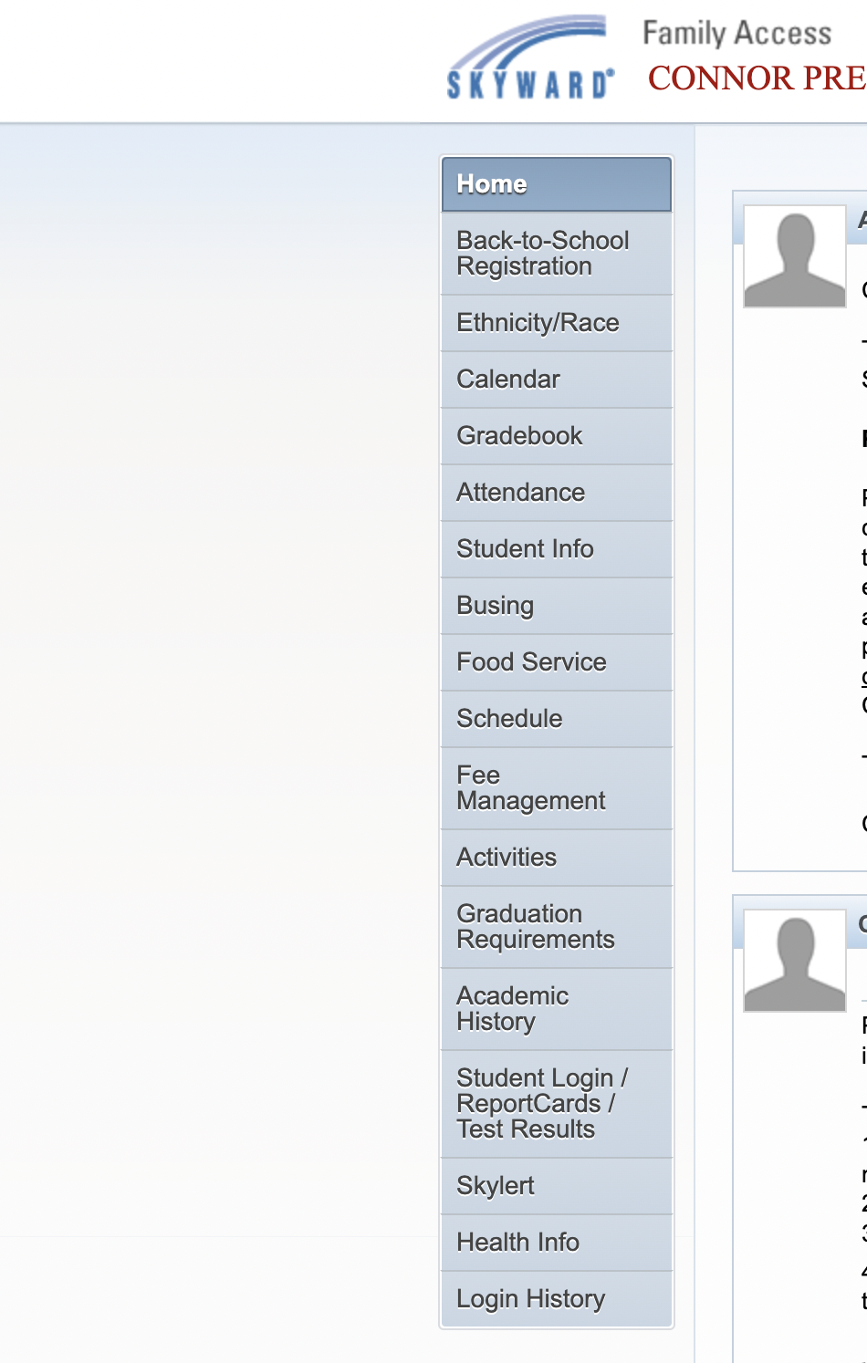
Proceed with all steps. Make sure you save and complete each step. On the last step, please make sure you close and save.

It will say that you have successfully registered your child.

If you have more than one child going to our school make sure you complete this process for each one.

